hdfs dfs -ls /
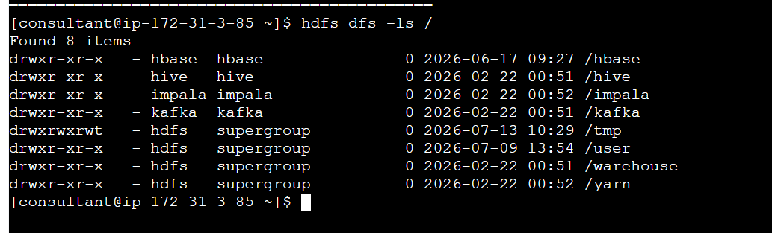
Created a employee.csv file on the server
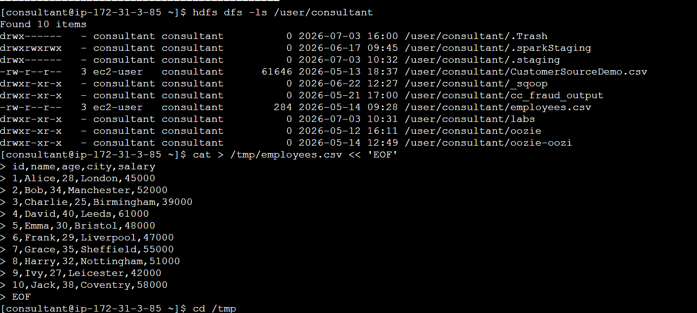

Adding the file to HDFS
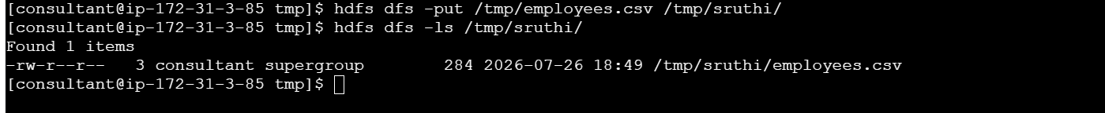
File created with 284 mb size
owner/user can read&write
Others can read
Checking if the file is there in hdfs
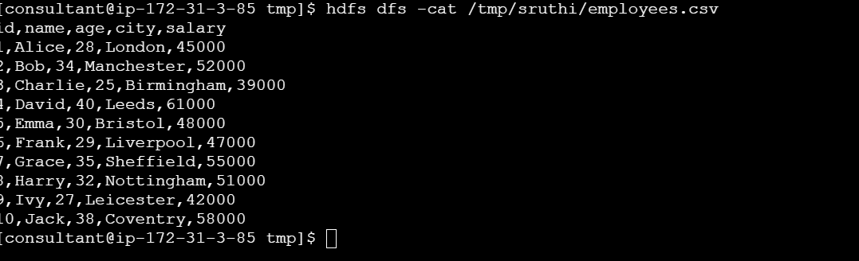
Checking file size

Setting replication to two
